

VILNIUS UNIVERSITY
ŠIAULIAI ACADEMY
BACHELOR PROGRAMME SOFTWARE ENGINEERING

Computer networks laboratory work No. 1

Student : Hanna Asiadouskaya
Lecturer: dr. Nerijus Ramanauskas

Šiauliai, 2024
Questions:
- Http 1.1
- My browser accepts English
- My IP address: 192.168.0.132, IP address of the server: 128.119.245.12
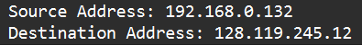
- Status code: 200
- Last modified: 1 May 05:59:01 GMT
- 128 bytes
- All headers are displayed in packet-listing window.
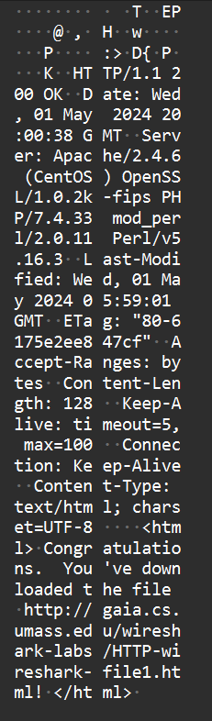

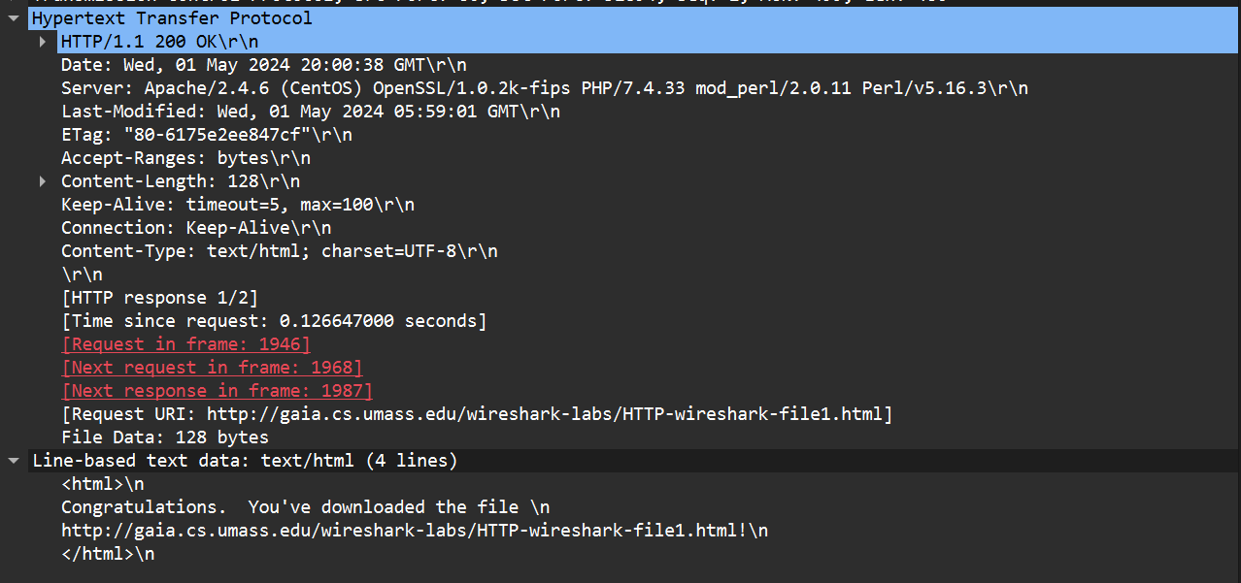

- No.
- The response was present
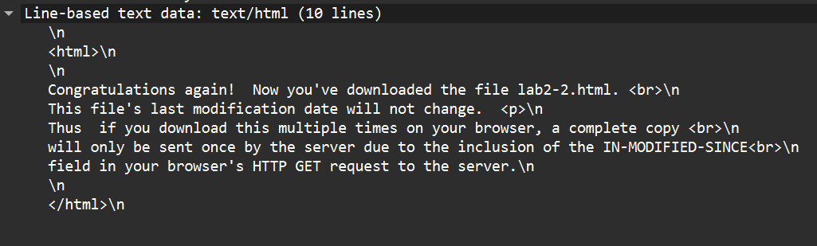
- Yes, IF-MODIFIED-SINCE: 1 May 05:59:01 GMT

- Status code of response was 304 Not modified. Response was not provided because the file has not been modified since the date.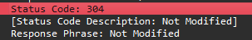
- My browser sent 1 GET request message. Packet number 63
- Packet number 83 contained response.

- Status code: 200, response: OK
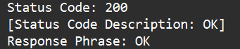

- 4 reassembled segments
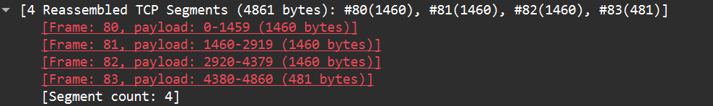
- Three GET requests were sent, to sites:
  - gaia.cs.umass.edu/wireshark-labs/HTTP-wireshark-file4.html
  - gaia.cs.umass.edu/pearson.png
  - kurose.cslash.net/8E_cover_small.jpg
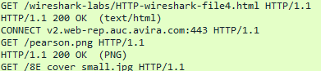
- Browser downloaded images serially because the first request and get happened before the second request.
- Status code is 401 and the response is Unauthorized. 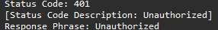
- After the entering of password new field Authorization appeared, which contains login information:

